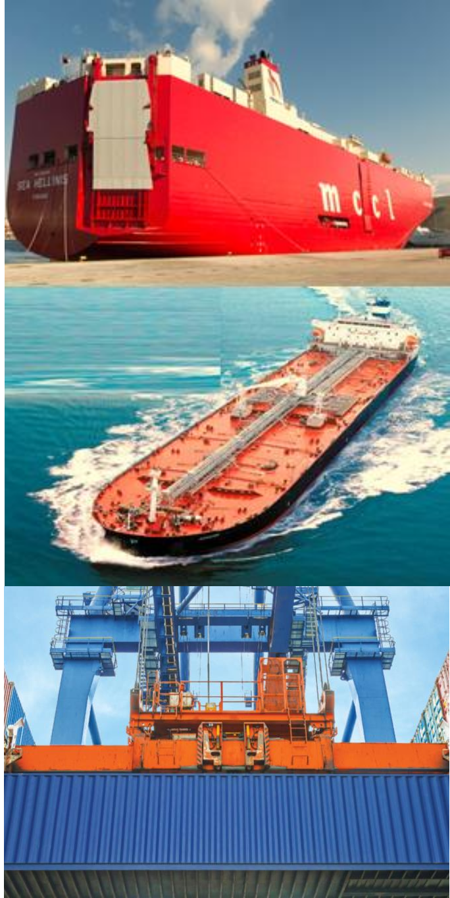



• **Williams Shipping Agencies S.A.E** as an Egyptian stock company to act as shipping agency and logistics service provider in all Egyptian ports for all types of vessels.

• Behind this success is a strong belief about customer service and doing business with integrity and abiding by business ethics.

• Information technology has become an essential tool not only as a knowledge base but also vital for providing high level of customers service that our agents and customers expect. In this respect, we have invested heavily in IT either in hardware or software to ensure the best service and meet customers’ needs. We have developed our own in-house logistics and shipping software that ensures efficient and effective control of our services. We have also spent a lot of time and effort to upgrade our ERP systems to be in line with the pace of technology.

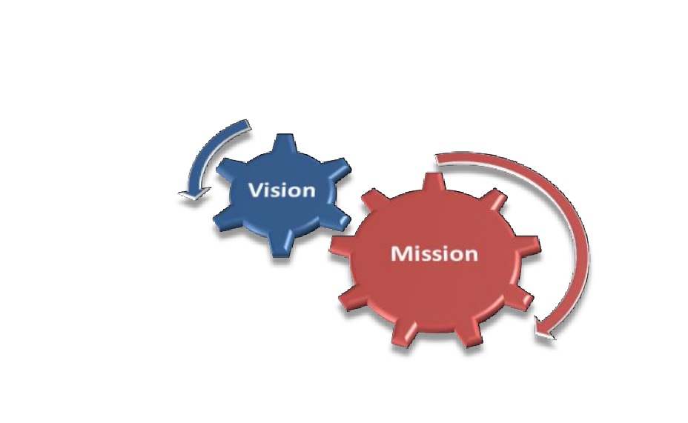Our **VISION** is to be amongst the top

regional innovators in the field of

shipping agency and logistics services

providers in order to maximize the value

added to our principals as well as

customers.

Our **MISSION** is to extend and enhance our services to our principals and customers, by providing high quality differentiated and innovative shipping and logistics services. We strive to grow and add value to our customers’ businesses. This is attained by providing comprehensive set of services, continuously investing in state-of-art technology and developing our staff to fully address our principals and customers’ needs.

Williams Shipping Agencies S.A.E

**Williams Shipping Organizational Chart & Business units**

































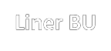

Williams Shipping Agencies S.A.E

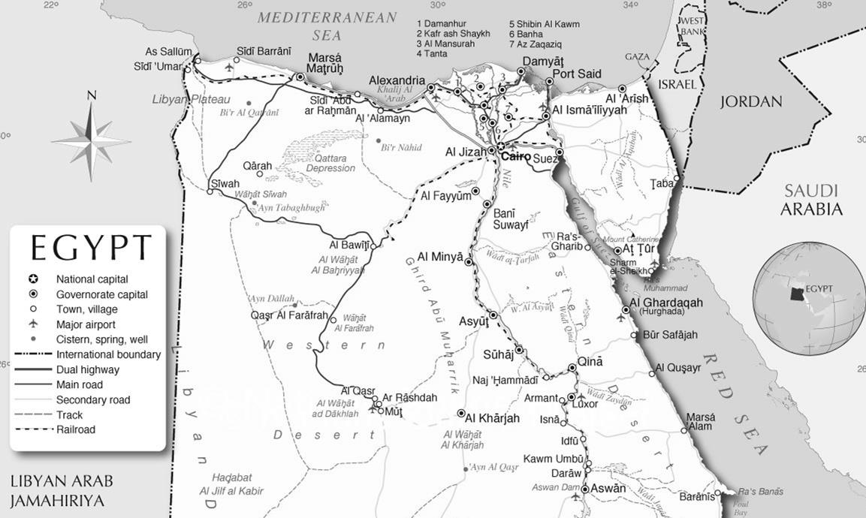

Williams Shipping Agencies S.A.E

**Human Resources**

Williams Shipping employees covered all Egyptian ports. Our HR team has developed their state-of- art system to cover the following:

• Training plans.

• Evaluation and periodic appraisal systems

• Recruitment

• Accurate job descriptions.

• Formal reporting system.

**IT Infrastructure**

• We have our in-house IT team for both hardware and software maintenance and

development.

• Mail server has built in anti-virus and anti-spam filter.

• All WAN and internet connections are dedicated leased lines with appropriate speed.

• We have deployed CISCO VOIP telephone system connecting all branches.

➢ Williams Shipping is perfectly positioned in this industry throughout a strong presence in all Mediterranean and Red Sea ports of Egypt specially: Alexandria, El-Dekheila, Abu Qir, Damietta, Port Said, Adabiya, Sokhna, and Safaga ports.

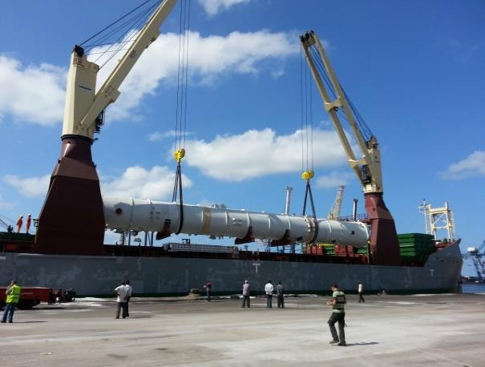➢ We handle diversified types of vessels such as, dry bulk carriers, tankers, general cargo and RORO vessels.

➢ As cited by our major clients, this remarkable milestone has been achieved due to our reliable and competent performance and an outstanding capability in managing the Ship - Port Interface daily challenges encountered in this global industry.

**Cargo Type**

Williams Shipping has a very well-experienced and a dedicated team who can handle any type of cargo vessels, with a special experience in handling the following:

• Grains

• Dry Bulk

• Liquid Bulk

• General cargo

• Roro

**Our Services and Activities Include:**

➢ **Timely definite reporting to our principals for all operational minutes relevant to vessels' attendance.**

➢ **Handling discharging/loading activities:**

• Arranging all port formalities in due time

• Updating all concerned parties with vessels’ status/prospects.

• Attendance on board by our port staff.

• Sending all related documents to all concerned parties including NOR and SOF

• Reviewing/arranging for issuance of vessel’s final D/A in accordance with port original invoices/vouchers received.

➢ **Protecting agency**

• We act as a protecting agent for our principals when other agents are appointed by counterparts, having been entrusted with this role we entirely cover vessels’ status during port stay, reporting relevant prospects and events to our principals while also carrying out all relevant matters that we may be assigned of.

➢ **Accurate and competitive D/A**

• Provide port disbursement estimates for calling vessels to be settled under final port disbursement in accordance with original official invoices and vouchers received from port authorities and concerned parties.

**Services and Activities**



➢ **Owner’s Services(Contd.)**

• Crew Change / Crew Sign in – sign off – visits

• Medical assistance to the crew

• Cash to Master

• Garbage /sludge/bilge/slop disposal

• Forwarding of Documents

• Bunker and provision supply and bonded stores supply.

• Repair and Maintenance.

• Customs clearance and delivery for import shipments to vessel

• Appointing any survey requested on behalf of our principals

• Any other owner’s matter requests from owners

➢ **Appointing and supervising stevedoring operation.**

➢ **Appointing and supervising warehousing operation**

➢ **Safety and marine pollution prevention**

➢ **Parcels' delivery**

➢ **Online vessels status, useful market information on the web**

➢ **Periodic ports and market reports to our principals**

➢ **Ship – to – ship transfer**

**Suez Canal Transiting Services**



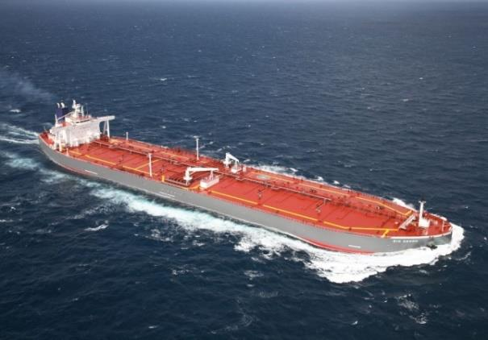➢ Williams Shipping is also well positioned in providing Suez Canal transiting services. Through our dedicated team in both ports of PortSaid and Suez we ensure smooth and cost effective transit services for ship owners who entrust us in this service.

• **Large Units SC Transiting:**

➢ We are experienced in arranging transit of floating docks which need special treatment to ensure smooth/fast transit.

 **We are a member of**





* Quality Management System

Williams Shipping quality management system is ISO 9001 / 2015

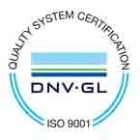 certified by DNV-GL

**Office & Contact Details**

**Head Office**

Damietta - New Damietta City

New Damietta ,quarter 5

Part 28 ,front of west parking

E-Mail : [operation@williamseg.com](mailto:operation@williamseg.com)

M : +201276655980

**Mediterranean Sea ports**

**( Alexandria- El Dekhila- Abu Qir- Damietta- Port Said)**

Operation Manager :

Mohamed Mustafa

M:+201003460033

**Red Sea Ports**

**(Suez-Adabiya- Hamraween- Safaga-Sokhna)**

Operation Manager :

Abdelrahman Mohamed

M: +201228666870



THANK YOU ..

Williams Shipping Agencies S.A.E.